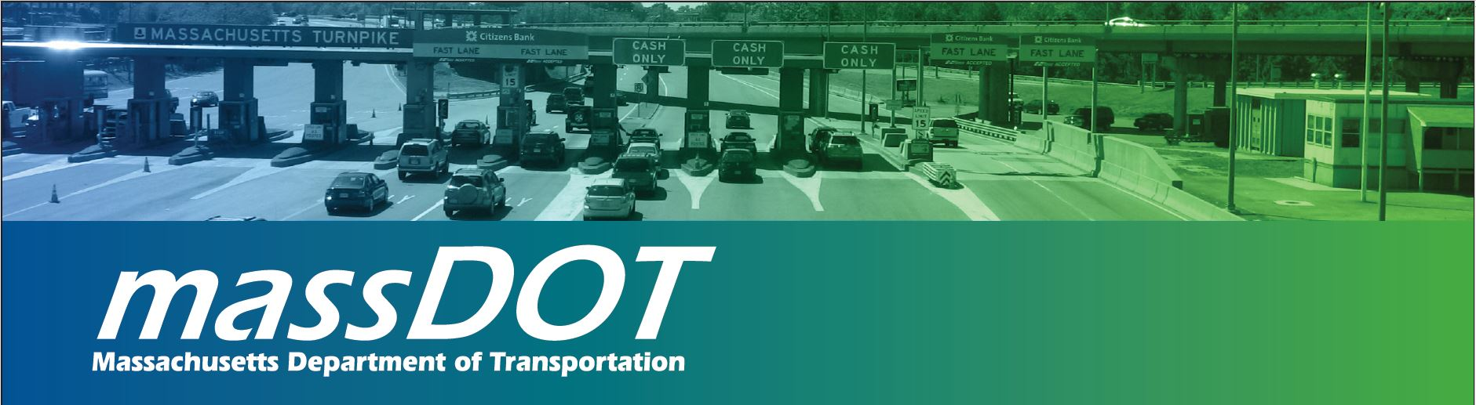

Sumner Tunnel Toll Plaza Demolition

and Roadway Reconstruction Project

Project Update Meeting

MassDOT will host a Sumner Tunnel Entrance Reconstruction and Toll Plaza Demolition Project Update Meeting to provide information about the proposed design of the tunnel entrance and toll booth elimination which will begin at a later date.

MassDOT will discuss the design and construction process as well as construction impacts such as traffic and other project related issues. This meeting will ensure that users of the Sumner Tunnel and neighboring communities are fully informed about the project’s design and construction.

If you are unable to attend a meeting, a copy of the presentation will be available at
https://www.massdot.state.ma.us/allelectronictolling
Public comments and questions may also be submitted by email AETinfo@dot.state.ma.us

Wednesday, August 30 – East Boston High School Auditorium
86 White Street, East Boston
6:30 p.m. – 8:30 p.m.

Locations are accessible to people with disabilities. MassDOT provides reasonable accommodations and/or language assistance free of charge upon request (including but not limited to interpreters in American Sign Language and languages other than English, open or closed captioning for videos, assistive listening devices and alternate material formats, such as audio tapes, Braille and large print) as available. For accommodation or language assistance, please contact Katy Zazzera by phone (857) 368-8986 or by email (Kathryn.Zazzera@dot.state.ma.us). Requests should be made as soon as possible prior to the meeting. For more difficult to arrange services including sign language, CART or language translation or interpretation, requests should be made at least ten (10) business days before the meeting.

